CSC 335: Data Communications and Networking I

**Final Exam**

# *Name: BEN WALKER_______________________________________________________*

**General Instructions:**

This exam is 24 hours long. It is due on June 30, 2018, 8 p.m.

Read the questions carefully to understand what is being asked. Avoid writing unnecessary things in the answers but write ***all*** the essential steps in solving any problem. Explain the steps and all assumptions you make for solving a problem or answering a question.

**There will be no partial credit for vague answers or unclear steps. I should be able to understand what you were trying to do without your verbal explanation later.**

1. Answer the following questions in **not more than eight lines** each: (5 × 3 = 15)
   1. Differentiate between a MAC address and an IP address in terms of function and characteristics. How does a computer obtain the mapping between another computer’s MAC address and its IP address? Explain clearly.

MAC address is specified at the hardware level while IP address is given at the software level. ARP allows the identification of the IP of another machine by its MAC address.

* 1. What is the function of MAC protocol? Why are MAC protocols needed in LANs?

MAC protocol controls Framing, Error Control, and Flow Control. They are needed to prevent communication issues from machines fighting over resources.

* 1. How is random access different from polling? When would you prefer one over the other?

Random access allows transmission as long as the channel is open, potentially denying transmission by other machines. Polling works in a round robin fashion, so each machine gets a chance to transmit before it moves to the next. In limited machine numbers random access is ok, but beyond that polling would be better so all machines can transmit.

* 1. What is a VLAN? Explain. Why use VLAN?

A VLAN is a Virtual Local Area Network. It is a fully digital connection of machines that cannot be accessed without permission being granted, and is not limited to computers on the same switch. It allows for easier administration and control over access than using other solutions, ex. Subnets to segregate machines onto differing networks.

* 1. What is the feature of TCP? How does TCP provide reliability? What is the feature of UDP? Why can UDP be used with more confidence on LANs than WANs?

TCP verifies reception of the data. This keeps the data integrity high. UDP does not verify and just transmits. On LANs there is less traffic and less of a chance of a dropped or corrupted packet.

1. The speed of a signal is 0.7 times the speed of light (propagation rate) on a UTP cable used for Ethernet. A computer “A”, connected to this cable starts transmitting a packet at time = 0s. If a computer “B” is at a distance of 500m, when would it detect the signal? How many bits would “A” have transmitted by the time “B” detects the signal, if the transmission rate is 1Gbps? (6)

0.000002382 Sec detection time.

2382 Bits.

1. A client application generates 10000 bytes to be sent to a server. TCP adds 160 bits as header for each Layer 4 segment and creates 10 segments. Each TCP segment is carried by an IP datagram with a 160 bit header. The IP datagrams form the payload of Ethernet, which has a 176 bit header and a 32 bit CRC. How many bits of data are sent on the physical medium to complete the transmission of all of the application data? (6)

14992 bits.

1. The initial sequence number of a TCP SYN packet is 43567. The server sends a SYN ACK packet with sequence number 2331. Draw a diagram showing the three-way handshake. Identify the sequence and acknowledgment numbers for the three TCP segments sent as part of the 3-way handshake. Also identify the flags that are set to 1 in each of the three segments. (5)

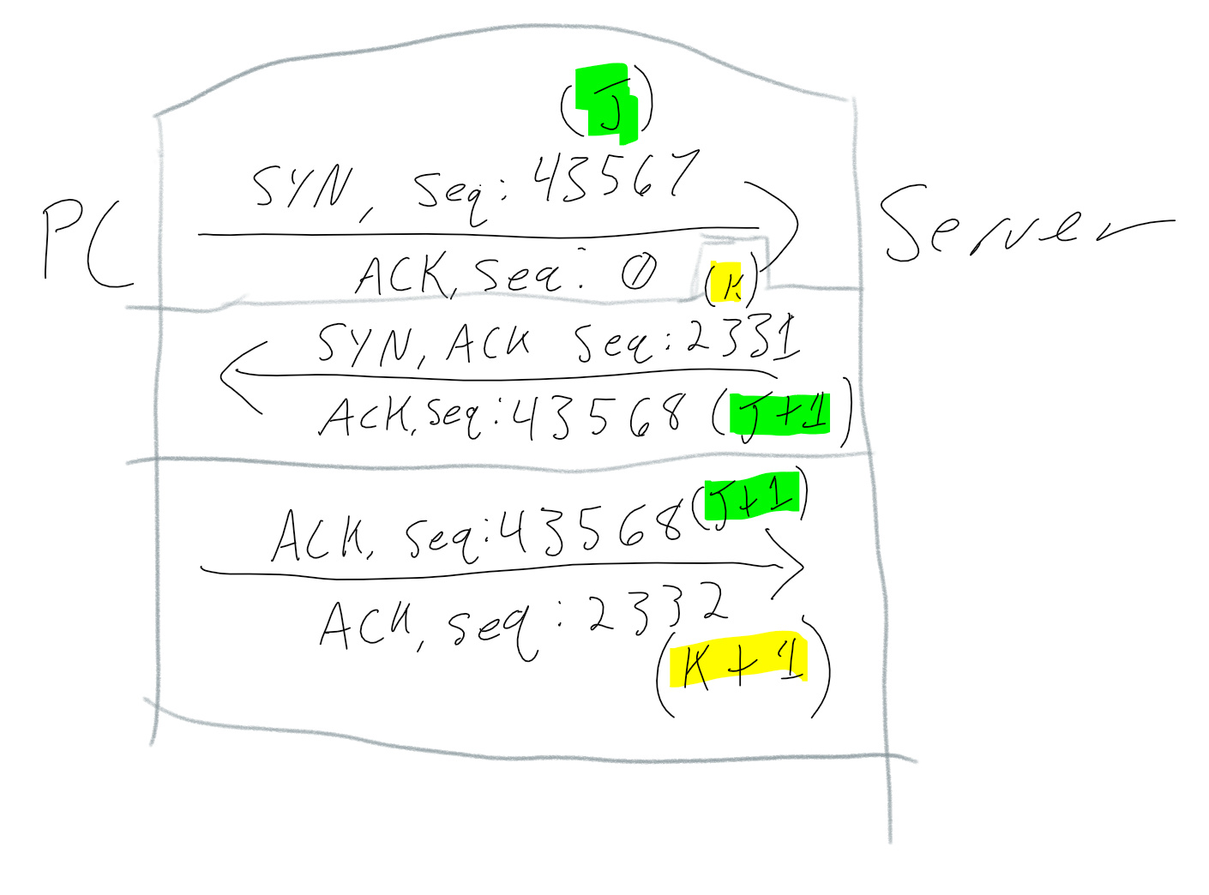

1. Assume that you have been assigned the 200.35.1.0/24 network block.
   1. Define an extended-network-prefix that allows the creation of 20 hosts on each subnet and define its corresponding subnet mask. (4)

200.35.1.0/27

255.255.255.224

* 1. What is the maximum number of hosts that can be assigned to each subnet? (2)

32

* 1. What is the maximum number of subnets that can be defined? (2)

12

1. **Bonus Question:** Decrypt the following ciphertext, that has been encrypted using the shift cipher, with a key *k* = 9. WNCFXATB (3)

NETWORKS